**Three tangents problem**

Prove that : GE = FH

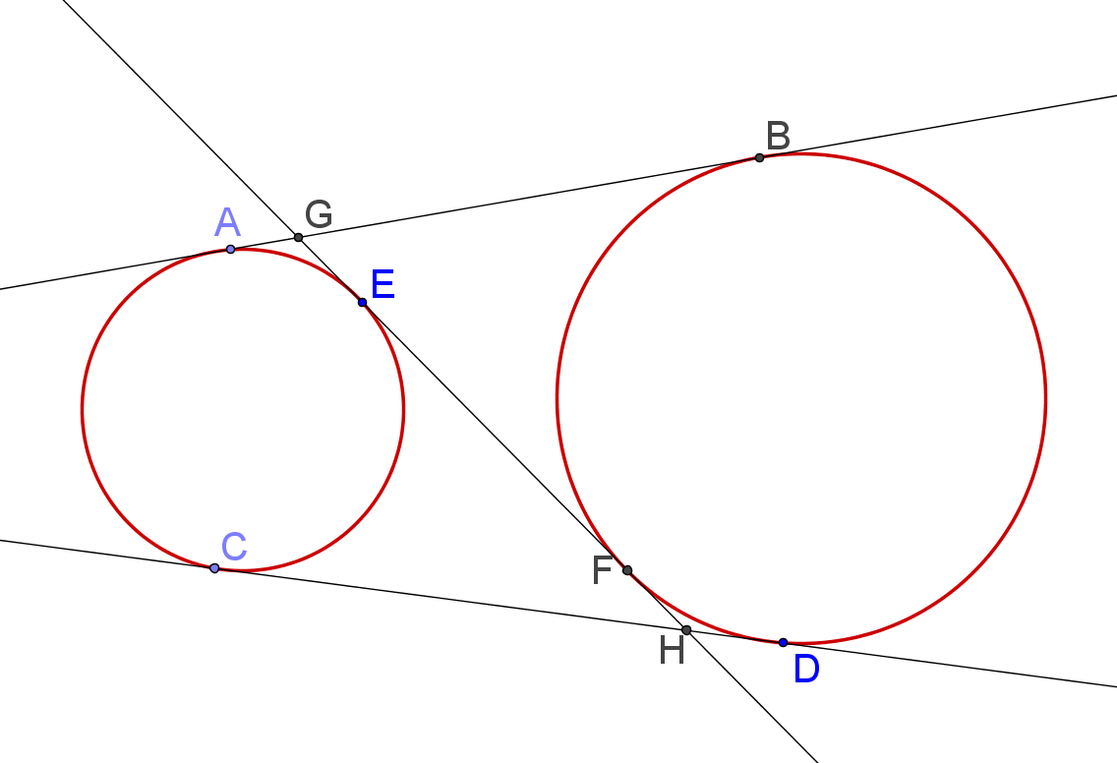



(1) AB = CD

(2) AB = AG + GB = GE + GE

= GE + (GE + EF)

= 2GE + EF

(3) CD = CH + HD = EH + FH

= (EF + FH) + FH

= EF + 2FH

(4) By (1), (2) and (3), GE = FH

Yue Kwok Choy

5, April, 2015